Master Document — Team Page Mock Sprint
Worked example — Team Byte Size
The git urls are fake – this is just an example
Make a copy of this document in your Team Channel Shared Folder

[Login Restyling Bootstrap] Task 1 —Write Requirements: Team Page & Login Styling
Role | BA — Kerry | Date | Thursday, 13 August 2026
Completion comment
Done: Documented required fields for the team page (team name, project name, per-member photo/name/role, about-us blurb) and confirmed login work is styling-only, no auth logic changes.
Deliverable: Requirements document, in docs folder of GitHub repo.
Note for next role: DEV – non-functional requirements (i.e. image size, text length) were arbitrarily chosen by me, if they need to be changed, we can consult on this.
Git URL: GrandPrixEcosystem-Team1/docs/DEMO-REQUIREMENTS.md at main · Grand-Prix-Ecosystem-Team-1/GrandPrixEcosystem-Team1

[Login Restyling Bootstrap] Task 2 — Design Login Style & Team Page Layout
Role | UX —Thierry Keane | Date | Thursday, 12 August 2026
Completion comment
Done: Produced high-fidelity mockups for the restyled login page and team page. The designs include the default and failed-login states, populated team-member cards, missing-information fallbacks, placeholder avatars, and the empty-team state. A clickable prototype was also created to demonstrate successful login, failed login, and logout flows.
Deliverables: Figma mockups and clickable prototype, and minimalist style guide PDF. All deliverables are linked from the team repository under “docs/UX/”
Note for next role: BA — please review the mockups against the requirements and validate that all required content, states, and behaviours have been addressed. Developers — please review and follow the style guide and developer handoff when implementing the login and team pages to ensure visual consistency with the approved designs

Teams URL: Thierry Keane: Mock Sprint - Mock Up completed | Capstone Programming Project 2026 > 25-Grand Prix-Ecosystem Operations — Team 1 | Microsoft Teams
Git URL (commit): https://github.com/Grand-Prix-Ecosystem-Team-1/GrandPrixEcosystem-Team1/commit/1698f64c84fdb76f23c8a7638d8af7f87c792657
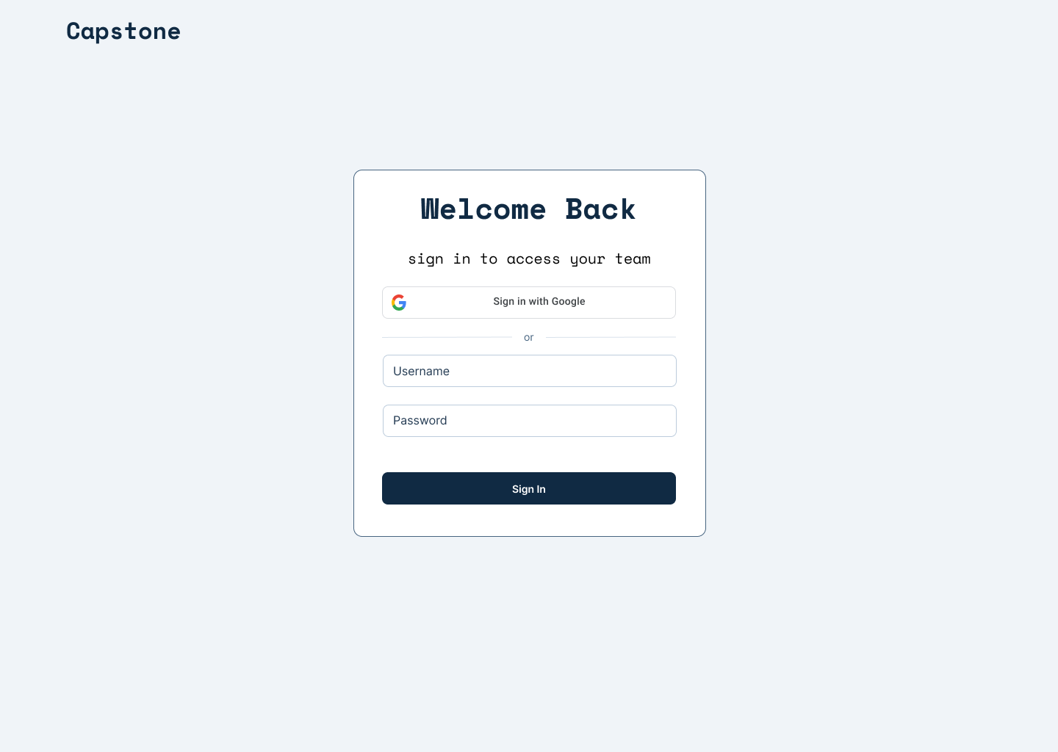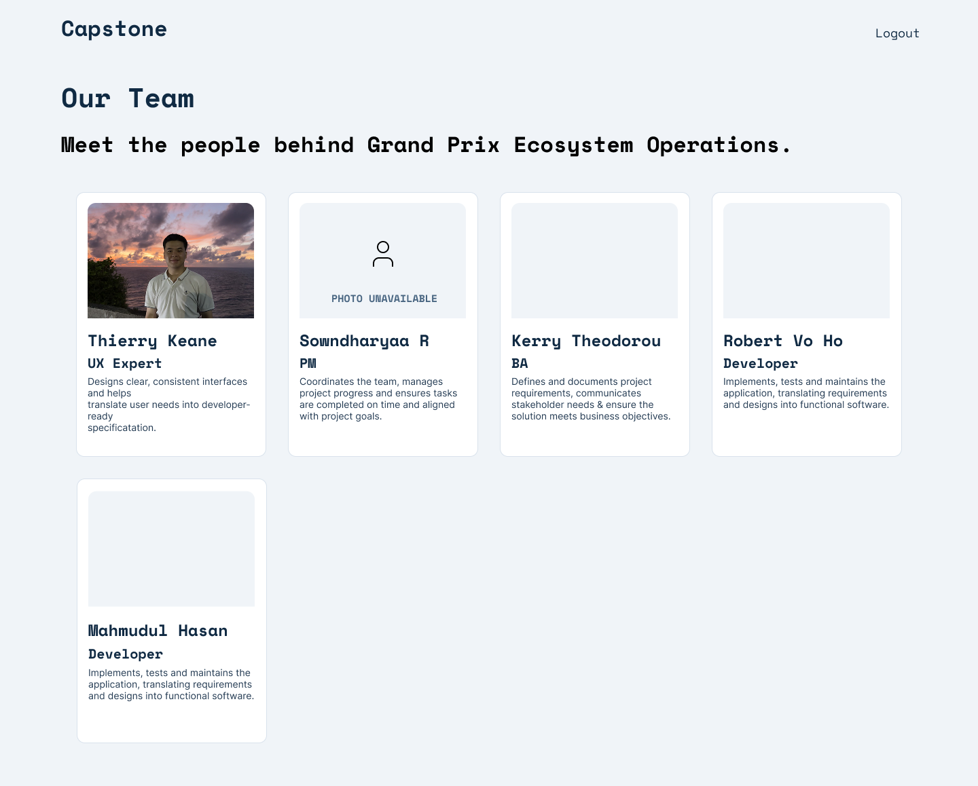

[Login Restyling Bootstrap] Task 3 — Validate Design Against Requirements
Role | BA — Kerry | Date | Tuesday, 13 August 2026
Completion comment
Done: Checked mockups against the requirements doc. All fields present, login scope stayed to styling only, placeholder-avatar and missing text field cases both covered. Approved as-is, no changes requested.
Deliverable: Design validation sign-off, formally approved on teams.
Note for next role: Dev — you're clear to build exactly to the Figma file, no open questions from BA's side.
Teams URL: Kerry Theodorou: Obviously this is a bit late (and I guess I have already informal... | Capstone Programming Project 2026 > 25-Grand Prix-Ecosystem Operations — Team 1 | Microsoft Teams

[Login Restyling Bootstrap] Task 4 — Style Login Page
Role | Dev 1 — Robert Vo-Ho | Date | Thursday, 13 August 2026
Completion comment
Done: Applied the approved login styling (colors, layout, branding). Confirmed auth logic, validation, and session handling are all untouched.
Deliverable: Branch/commit with the styling changes.
Note for next role: Nothing blocking — login page styling is complete and ready for review.
Git URL (commit): https://github.com/Grand-Prix-Ecosystem-Team-1/GrandPrixEcosystem-Team1/commit/1e1c5f24dfe7adbc105db9a02c887467e6b02003

REAL OUTPUT — rendered login page
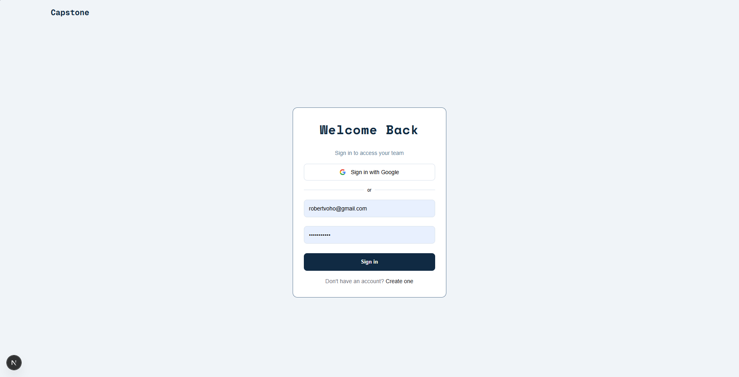

[Login Restyling Bootstrap] Task 5 — Build Team Page & Auth Redirect
Role | Dev 1 — Robert Vo-Ho | Date | Thursday, 13 August 2026
Completion comment
Done: Built the team page according to the approved design, including team member cards with name, role, blurb, photo/placeholder handling, missing-information warnings, and an empty-state display when no team members are available. Added authentication protection so unauthenticated users are redirected to the login page.
Deliverable: Branch/commit with the team page and route guard.
Note for next role: Nothing blocking – team page is ready for testing against the deployed environment once deployment is available.
Git URL (commit): https://github.com/Grand-Prix-Ecosystem-Team-1/GrandPrixEcosystem-Team1/commit/8705388440c0b8dd592a4b18e1651f44551ea7f0
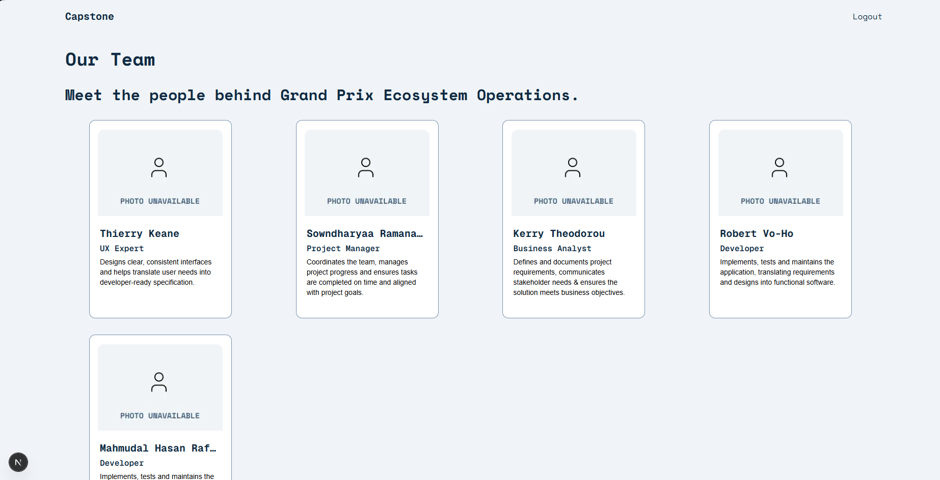

[Login Restyling Bootstrap] Task 6 — Test Login → Redirect → Team Page Flow
Role | Dev 2 — Mahmudul Hasan Rafid Khan | Date | Thursday, 6 August 2026
Completion comment
Done: Tested the complete login to redirect to team page flow on the deployed environment. Verified successful login, correct redirection to the team page, and correct rendering of team member information including photo, role, and blurb. Confirmed that long text content expands correctly without breaking the page layout.
Note for next role: Happy path testing completed successfully with no blocking issues identified. Proceeded with edge case testing.

[Login Restyling Bootstrap] Task 7 — Test Edge Cases & Log Bugs
Role | Dev 2 — Mahmudul Hasan Rafid Khan | Date | Thursday, 6 August 2026
Completion comment
Done: Tested key edge cases including invalid login credentials, direct access to the team page without authentication, team members without photos, and unusually long profile blurbs. No bugs were identified during testing.
Deliverable: Test report.
Note for next role: All tested edge cases passed successfully, with no outstanding issues requiring developer fixes before final review.
Git URL (test report): https://github.com/Grand-Prix-Ecosystem-Team-1/GrandPrixEcosystem-Team1/blob/feature/team/docs/testing/login-team-page-test-report.md
Git URL (PR comment): https://github.com/Grand-Prix-Ecosystem-Team-1/GrandPrixEcosystem-Team1/pull/11

[Login Restyling Bootstrap] Task 8 —Deploy
Role | Dev 1 — Robert Vo-Ho | Date | Saturday, 15 August 2026
Completion comment
Done: Enabled the deployment workflow by renaming deploy.yml_notinuse to deploy.yml. Configured the project for deployment through Vercel and confirmed the deployment setup is ready. No application logic was changed.
Deliverable: Live Vercel deployment with deployment workflow changes in the branch/commit
Note for next role: Nothing blocking —deployment setup is complete and ready for review.
Git URL (commit): https://github.com/Grand-Prix-Ecosystem-Team-1/GrandPrixEcosystem-Team1/commit/4ad678adf4649c2ee755fb96d7228c1a736a9c51
Live URL: https://grand-prix-ecosystem-team1-frontend.vercel.app/auth/signin
REAL OUTPUT — Vercel Deployment

[Login Restyling Bootstrap] Task 9 — Final Review & Sign-Off
Role | PM — Sowndharyaa Ramanathan Manikandan | Date | 15.08.2026
Completion comment
Done: Reviewed the feature end-to-end against the requirements and design. Verified every prior task's checklist and completion comment. Everything matches — approved.
Deliverable: Sign-off note.
Note for next role: None — feature complete, board closed out.
Git URL: https://github.com/team-byte-size/team-page/blob/main/docs/signoff.md
If the GitHub URL provided above is not working, please refer to the GitHub link below.
Git URL: https://github.com/Grand-Prix-Ecosystem-Team-1/GrandPrixEcosystem-Team1/commit/15f214f2e91ff1823d2efe5543778e9a8b9aeb01#diff-d85f60ed654af8512e8fbf3342978d98637257ee98972b1fdd41ba1609daddba

